**Introduction to AI In Business**

## Overview

* AL technology has the potential to rapidly change our world for the better.
* Example like improving outcomes for patients, able to scale customer service, reducing drought and water usage and etc.

## What is AI

* AI stands for Artificial Intelligence, more recently the abbreviation can also stand for Augmented Intelligence.
* “Artificial Intelligence is the science and engineering of making computers behave in ways that, until recently we thought required human intelligence.” – Andrew Moore, 2017

## What can AI do?

* Facial recognition that used to recognize faces by social media. Computer can easily recognize individual people with emotion and even micro expressions that people might not aware of.
* Automatic text recognition that used to automate expense reporting by taking pictures of the receipts.
* Computer vision technology using semantic segmentation can take every pixel in an image and assign it to a particular object.
* For application perspective, computer vision is often used in social media use case. Big brands will use it to do sentiment analysis and natural language processing.
* Speech recognition is used but tricky in terms of human level computation in real-world environments. It has challenges like:
* Noisy environments
* Accented speech
* Speaking styles and languages with limited training data
* Understanding speech
* All different types of audio recognition that not just transcribing speech, such as recognizing failures by listening to engines.
* Natural language processing that has technique such as filtering out hate speech in social media platforms.
* AI also can be use to give advice on the quality of your writing.

## The AI Universe

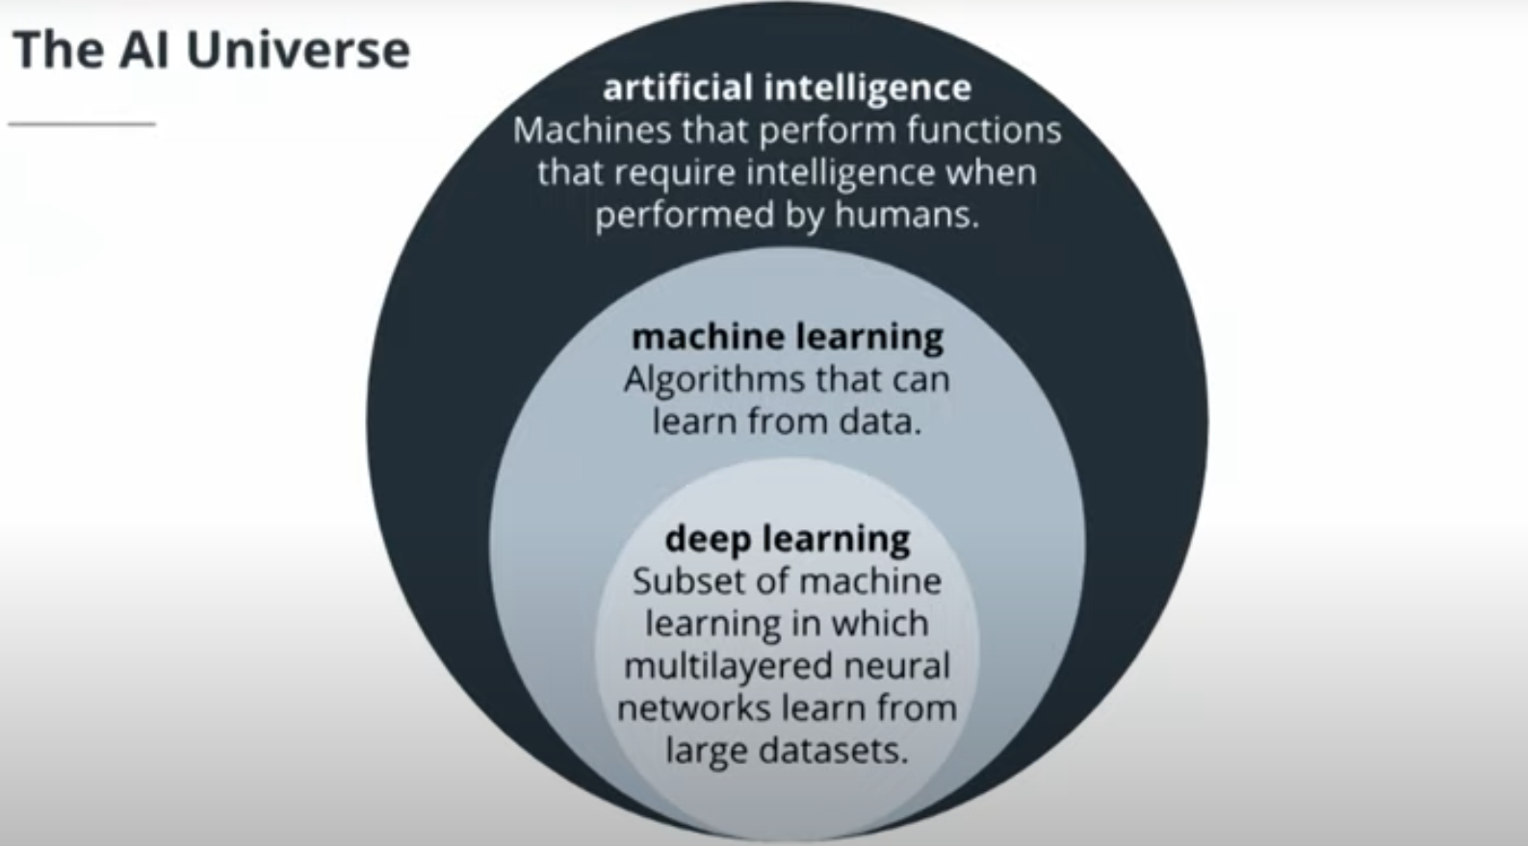

* “[The term AI] is aspirational, a moving target based on those capabilities that humans posses but which machines do not.” – Zachary Lipton

## Why Deep Learning

* Deep learning can process and learn from much, much more data than previous approaches, which with the right data, can really improve the performance of a model against a desired outcome.
* AI is so relevant ***now*** because of three factors:
* Compute power
* Data availability
* Cost
* Supercomputers measure their performance in FLOPS (floating point operations per second – which computers use to do any calculation). Compute power nowadays is a lot more to compare decades ago
* The amount of data being created is growing exponentially, which is hard for human to process but is really easy and really good for deep learning and machine learning techniques.
* Cost has come down drastically over time, speaking of accessing the compute power and data. Running large-scale computations required for deep learning techniques is a lot more accessible for a lot more people.

**Quiz**

1. What is Machine Learning? (Choose 3 Answers)
2. Artificial Intelligence
3. Machine Learning
4. Data Statistics
5. Deep Learning

Answer: a, b, d

1. Deep Learning is a subfield of Machine Learning.
2. TRUE
3. FALSE

Answer: a

3. Artificial Intelligence is superset of ________________ & _____________________ .

a) Machine Learning & Neural Networks

b) Machine Learning & Deep Learning

c) Deep Learning & Neural Networks

Answer: b